***Insert at Begin of Doubly Linked List***

**Add a node at the front:**

The new node is always added before the head of the given Linked List. And newly added node becomes the new head of DLL. For example, if the given Linked List is **1->0->1->5**and we add an item **5**at the front, then the Linked List becomes **5->1->0->1->5**. Let us call the function that adds at the front of the list push(). The push() must receive a pointer to the head pointer because the push must change the head pointer to point to the new node.

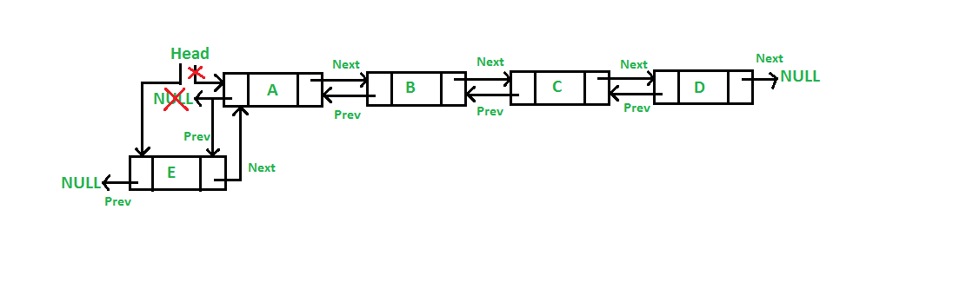

Below is the implementation of the 5 steps to insert a node at the front of the linked list:

C++Java

// Adding a node at the front of the list

public void push(int new_data)

{

/* 1. allocate node

* 2. put in the data */

Node new_Node = new Node(new_data);

/* 3. Make next of new node as head and previous as NULL

*/

new_Node.next = head;

new_Node.prev = null;

/* 4. change prev of head node to new node */

if (head != null)

head.prev = new_Node;

/* 5. move the head to point to the new node */

head = new_Node;

}

**Time Complexity: O(1)**  
**Auxiliary Space: O(1)**